**CS-330 Comp Graphics Module Two Milestone Proposal**

**Shelayah Robinson**

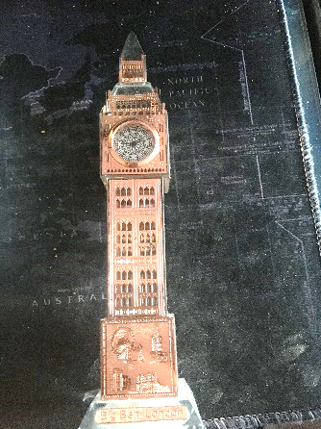

For my object I would like to recreate in 3D, I have selected a rose gold replica of Big Ben. The structure displays an example of the use of four of the six primitive shapes. Which would be: Cube, Plane, pyramid, Sphere, and Torus. In my mind, I think this would be a good choice because it gives me practice on not only combining shapes, but also identifying what shapes I would need in order to create the object.

For my object, I would use the cube shape for the clock area of the tower, cube for the upper section of the tower, and a cube for the bottom of the tower. I would consider using a pyramid for the top of the tower. I would consider using a torus shape for the rim of the clock area; a plane for the mid-section of the tower; and lastly, I would use a sphere for the arms in the clock area. The selection of shapes makes sense when creating my 3D representation because there are the shapes that are apparent on my representation. I think the one challenging area would be the top of the tower, because there is a section of the tower that looks similar to a pyramid, but rather a rhombus. In order to achieve these shapes, I would have to distort some shapes in order to get everything to look similar.